
PREMIER UNIVERSITY CHATTOGRAM
DEPARTMENT OF COMPUTER SCIENCE AND ENGINEERING
REPORT
COURSE NAME | Computer Networks
COURSE CODE | CSE 3568
PROJECT NAME | TELECOMMUNICATION SYSTEM NTEWORK DESIGN
DATE OF SUBMISSION | 21/10/2025

SUBMITTED BY
- NAME: MD ARAFAT SIRAJ ID: 0222220005101030
- NAME: PRIYAM SHRAMA ID: 0222220005101018
- NAME: ABIR AHAMED OMI ID: 0222220005101021
SESSION: SPRING-2025
BATCH: 42nd
SECTION: A
SUBMITTED TO

ABSTRACT
This project presents the design, implementation, and testing of a complete telecommunication system for PUC TELCO, connecting its headquarters, branches, and ISP. The design integrates core networking technologies such as subnetting, OSPF routing, VLAN segmentation, centralized DHCP/DNS services, secure ACL-based access, NAT/PAT for internet access, VoIP for voice communication, and IoT for smart infrastructure management.
The system was built and simulated in Cisco Packet Tracer. It demonstrates advanced engineering knowledge in telecommunication system design, incorporating problem-solving approaches, adherence to standards, and consideration of societal impacts such as data security and service accessibility. Testing and verification confirmed that the system meets organizational requirements: secure communication, controlled resource access, guest isolation, and seamless service integration.

Table of Contents
ABSTRACT 1
INTRODUCTION 4
Knowledge Profile Coverage: 4
Complex Engineering Problem Attributes: 4
Complex Engineering Activities: 5
LITERATURE REVIEW: 5
PROBLEM STATEMENT: 6
PROJECT REQUIREMENTS: 6
SYSTEM DESIGN: 6
Logical Diagram: 7
IMPLEMENTATION: 8
Subnetting: 8
VLANs: 8
Routing: 8
DHCP Configuration: 8
DNS & HTTP Services 8
VoIP 8
ACLs 9
NAT/PAT 9
IoT Integration 9
Security Measures 9
RESULT & DISCUSSION: 9
CONCLUSION: 9
RECOMMENDATIONS 10
REFERENCES: 10
APPENDICES: 11
APPENDIX-A: Full Subnetting Table: 11
APPENDIX-B: IP Addressing Scheme: 11
APPENDIX-C: ACL Configuration Commands 12
APPENDIX-D: DHCP Pool Configurations 13
APPENDIX-E: OSPF Process IDs and Router IDs 13
APPENDIX-F: VoIP Dial Plan (111–120) 13
APPENDIX-G: Sample Website 14
APPENDIX-H: REMOTELY IOT MONITORING AND CONTROL: 15
APPENDIX-I: EMAIL 15
APPENDIX-J: COMPLETE NETWORK 16

TELECOMMUNICATION SYSTEM NETWORK DESIGN
INTRODUCTION:
The PUC TELCO project focuses on designing and deploying a professional enterprise network that integrates multiple technologies to meet the communication, security, and service needs of the organization. The network spans across headquarters, branch offices, and an ISP link, with centralized services such as DHCP, DNS, HTTP, Email, IoT, and VoIP.
The system was designed according to a hierarchical model:
- Core Layer: Core switch with VLAN segmentation.
- Distribution Layer: Headquarters and branch routers.
- Access Layer: End devices, servers, WLAN, and IoT devices.
- Service Layer: Centralized servers (DNS, DHCP, Email, HTTP, Data, IoT).

Knowledge Profile Coverage:
- Depth of Knowledge: Applied advanced networking principles including subnetting, OSPF routing, VLAN segmentation, and ACL-based security.
- Knowledge of Disciplines: Integrated telecommunication engineering with networking, IoT, and VoIP technologies.
- Engineering Practice: Configured routers, switches, WLC, and servers using industry-standard Cisco Packet Tracer tools.
- Research & Investigation: Analyzed real-world enterprise network requirements for scalability and security.
- Problem Analysis: Addressed issues of inter-branch communication, VLAN isolation, and resource access control.
- Design & Development: Designed an end-to-end hierarchical topology with redundancy, subnetting, and logical addressing.
- Engineering Tools & Techniques: Utilized Cisco IOS commands, ACLs, DHCP pools, and NAT/PAT configurations.
- Social & Environmental Impact: Considered secure communication, minimized resource misuse, and improved service accessibility.

Complex Engineering Problem Attributes:
- Depth of Knowledge: Required in-depth knowledge of advanced networking protocols.
- Wide-Ranging or Conflicting Issues: Balanced security requirements with accessibility across conflicting VLANs.
- Abstract Thinking & Analysis: Involved abstract problem-solving in IP planning and ACL security.
- Infrequently Encountered Issues: Managed uncommon issues like multi-server email handling and IoT service restrictions.
- Adherence to Standards: Ensured compliance with networking standards (IPv4, subnetting).
- Stakeholder Conflicts: Resolved conflicts between stakeholder groups (Guest vs. Admin access).
- Interdependent Sub-Problems: Addressed interdependent sub-problems (routing, ACLs, VLAN segregation, NAT).

Complex Engineering Activities:
- Range of Resources: Used multiple hardware/software resources (routers, servers, WLC, IoT devices).
- Level of Interaction: Required interaction between heterogeneous systems (LAN, WLAN, VoIP, IoT).
- Innovation: Introduced innovation by integrating IoT with enterprise networks.
- Consequences for Society and the Environment: Considered impact on end-users, business operations, and data security.
- Familiarity: Incorporated both familiar enterprise services (HTTP, Email) and advanced configurations (multi-server, ACL-based IoT).

LITERATURE REVIEW:
Enterprise networking requires efficient IP planning, secure communication channels, and scalable infrastructure. Studies on corporate telecommunication systems highlight the importance of VLAN segmentation, dynamic addressing via DHCP, secure access using ACLs, and service integration. Industry trends also indicate the growing adoption of IoT and VoIP as part of modern networks. The PUC TELCO project builds upon these principles, adapting them to real-world requirements. Enterprise networking relies on layered architecture, VLAN segmentation, and routing protocols for scalability and efficiency. Prior studies emphasize:
- Subnetting prevents address wastage and ensures efficient IP management.
- VLANs improve security and traffic segmentation.
- ACLs are essential for access control.
- OSPF is preferred in enterprise environments for dynamic routing.
- NAT/PAT allows private networks to access the internet efficiently.
- IoT integration requires wireless management via WLC.
- VoIP reduces communication costs and integrates with data networks.
- This project incorporates all these industry best practices in a unified telecommunication design.

PROBLEM STATEMENT:
PUC TELCO required a scalable, secure, and service-oriented network that:
- Interconnects headquarters, two branches, and ISP.
- Provides centralized services (DHCP, DNS, HTTP, Email, IoT, Data).
- Segments users into VLANs (Admin, Guest, LAN, WLAN, VoIP).
- Ensures Guest VLAN cannot access internal resources but can use internet.
- Restricts IoT access to Admin, LAN, WLAN only.
- Restricts Data storage access to Admin VLAN only.
- Provides VoIP numbering (111–120) for internal calls.
- Ensures secure internet access using NAT/PAT.

PROJECT REQUIREMENTS:
- Subnetting: 19 subnets across different mask sizes (/24, /28, /30).
- Routing: OSPF across all routers.
- VLANs: Admin (99), Guest (11), LAN (50), WLAN (60), VoIP (101).
- DHCP: Centralized at 10.10.10.5.
- DNS: Resolves puc.tel, isp.co, iot.com, wlc.cisco.
- Servers: DNS, DHCP, HTTP, IoT, Email, Data storage.
- VoIP: Voice gateway with numbers 111–120.
- ACLs:
- Guest isolated from VLANs.
- IoT accessible only by Admin, LAN, WLAN.
- Data accessible only by Admin.
- NAT/PAT: For Headquarters and Branches.
- IoT: Connected via WLC LAPs and managed via IoT server.

SYSTEM DESIGN:
The design follows a hierarchical model:
- Core Layer: Core switch handling VLANs and inter-VLAN routing.
- Distribution Layer: Headquarters and branch routers.
- Access Layer: VLAN endpoints, IoT, VoIP, WLAN, Guest users.
- Service Layer: DNS, DHCP, HTTP, IoT, Data storage, and Email servers.

Logical Diagram:

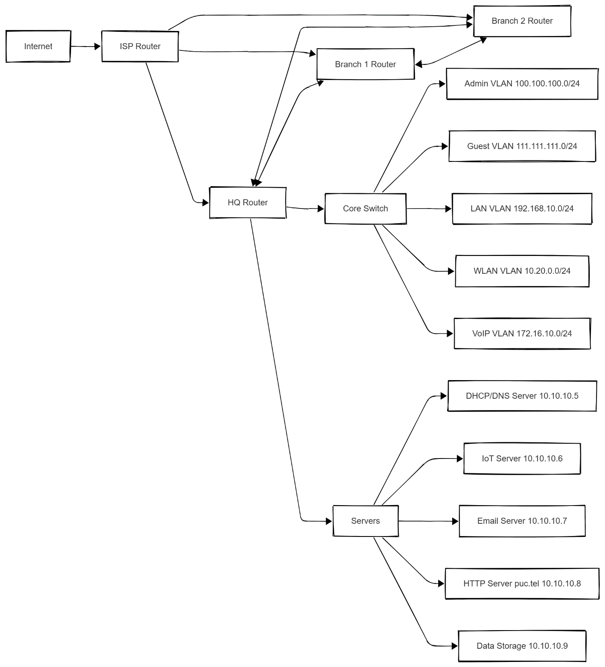

IMPLEMENTATION:

Subnetting:
Subnet | Network Address | Mask | Hosts | Use Case
#1 | 30.30.30.0/24 | 255.255.255.0 | 254 | Internet
#2 | 20.20.20.0/30 | 255.255.255.252 | 2 | ISP Link
#3 | 10.10.10.0/28 | 255.255.255.240 | 14 | Servers
… | … | … | … | VLANs & Branch links
  - (Full 19-subnet plan attached in Appendix- A)

VLANs:
- VLAN 99 - 100.100.100.0/24 (Admin).
- VLAN 11 - 111.111.111.0/24 (Guest).
- VLAN 50 - 192.168.10.0/24 (LAN).
- VLAN 60 - 10.20.0.0/24 (WLAN).
- VLAN 101 - 172.16.10.0/24 (VoIP).

Routing:
Configured OSPF across headquarters, Branch 1, Branch 2 and ISP.
Router IDs:
- HEADQUARTERS = 5.5.5.5
- BRANCH 1 = 3.3.3.3
- BRANCH 2 = 4.4.4.4
- ISP = 2.2.2.2
- INTERNET=1.1.1.1
- CORE SWITCH=6.6.6.6
All interfaces advertised into OSPF area 0,1 AND 2

DHCP Configuration:
- DHCP server’s IP 10.10.10.5.
- Pools for all VLANs (Admin, Guest, LAN, WLAN).
- Router Configured DHCP in VOICE GATEWAY for IP phones.

DNS & HTTP Services
- puc.tel → 10.10.10.8 (HTTP).
- isp.co → 30.30.30.1.
- iot.com → 10.10.10.6.
- wlc.cisco → 10.20.0.1. (WLC GUI)

VoIP
IP Phones with VOICE GATEWAY router’s Telephony-service with assigned numbers (111–120). It is Configured for inter-department calls.

ACLs
- IoT (10.10.10.6) → Only Admin (100.100.100.0/24), LAN (192.168.10.0/24), WLAN (10.20.0.0/24).
- Data Storage (10.10.10.9) → Only Admin VLAN (100.100.100.0/24).
- Guest (111.111.111.0/24) → Blocked from all VLANs, only allowed to internet.

NAT/PAT
PAT is configured on Headqaurters, BRANCH1, BRANCH2 routers for internet access via ISP.

IoT Integration
- IoT devices connected to LAPs of WLC.
- IoT server provides remote monitoring and control.

Security Measures
- Extended ACLs for access control.
- VLAN-based segmentation.
- NAT masking internal IPs.
- Testing & Verification
- Ping, traceroute between VLANs.
- DNS resolution verified.
- Email tested on single and dual server setup.
- Internet access verified from all VLANs.
- Guest cannot access internal VLANs.
- Admin access to Data & IoT verified.
- VoIP calls successful.
- DNS resolves puc.telco, isp.co, iot.com, wlc.cisco.
- VoIP calls tested successfully.

RESULTS:
The system successfully interconnected multiple branches, headquarters, and ISP. Services like DHCP, DNS, Email, HTTP, and IoT were accessible based on ACL rules. VoIP provided seamless internal communication. Guest VLAN isolation enhanced security, while PAT ensured efficient internet usage. The project demonstrates how theoretical networking principles (subnetting, routing, VLANs) apply to complex real-world scenarios.

DISCUSSION:
In the results, we achieved all goals — full connectivity, VLAN isolation, ACLs, NAT, and proper services.
But we faced some challenges. At first, there were IP conflicts during subnetting. ACL rules were tricky, sometimes blocking services unintentionally. DNS resolution also gave delays in Packet Tracer.
We considered alternatives. For routing, we used OSPF because it is scalable and widely supported. RIP could have been used since it is simple and easy to configure, but it does not scale well for larger networks. For NAT, we used PAT to save addresses, but Static NAT would give more control. For simulation, we used Packet Tracer, though real devices would provide more realistic performance.
The advantages of our design are easy scalability, strong security with ACLs, and cost-effectiveness since Packet Tracer is free. The disadvantage is that Packet Tracer is limited no real-world latency or advanced testing.
So, in discussion, the project worked successfully, but improvements are possible with advanced tools and methods.

CONCLUSION:
The PUC TELCO network was successfully designed and implemented with scalability, security, and service integration in mind. The project achieved its goals of centralized service management, VLAN-based access control, and branch interconnectivity. It also demonstrates the practical application of engineering knowledge in solving complex telecommunication challenges.

RECOMMENDATIONS:
- Implement IPv6 for future scalability.
- Deploy firewalls.
- Use cloud backup for data storage.
- Extend IoT services to smart surveillance.

REFERENCES:
- Cisco Networking Academy – CCNA Routing and Switching Curriculum.
- Cisco Systems – Official Configuration Guides.

APPENDICES:

APPENDIX-A: Full Subnetting Table:

Subnet # | Network Address | First Usable IP | Last Usable IP | Broadcast Address | Subnet Mask | Prefix
1 | 30.30.30.0 | 30.30.30.1 | 30.30.30.254 | 30.30.30.255 | 255.255.255.0 | /24
2 | 20.20.20.0 | 20.20.20.1 | 20.20.20.2 | 20.20.20.3 | 255.255.255.252 | /30
3 | 10.10.10.0 | 10.10.10.1 | 10.10.10.14 | 10.10.10.15 | 255.255.255.240 | /28
4 | 1.1.1.0 | 1.1.1.1 | 1.1.1.254 | 1.1.1.255 | 255.255.255.0 | /24
5 | 1.1.2.0 | 1.1.2.1 | 1.1.2.254 | 1.1.2.255 | 255.255.255.0 | /24
6 | 1.1.3.0 | 1.1.3.1 | 1.1.3.254 | 1.1.3.255 | 255.255.255.0 | /24
7 | 10.30.30.0 | 10.30.30.1 | 10.30.30.2 | 10.30.30.3 | 255.255.255.252 | /30
8 | 1.0.0.0 | 1.0.0.1 | 1.0.0.2 | 1.0.0.3 | 255.255.255.252 | /30
9 | 1.0.1.0 | 1.0.1.1 | 1.0.1.2 | 1.0.1.3 | 255.255.255.252 | /30
10 | 1.0.2.0 | 1.0.2.1 | 1.0.2.2 | 1.0.2.3 | 255.255.255.252 | /30
11 | 192.168.10.0 | 192.168.10.1 | 192.168.10.254 | 192.168.10.255 | 255.255.255.0 | /24
12 | 192.168.11.0 | 192.168.11.1 | 192.168.11.254 | 192.168.11.255 | 255.255.255.0 | /24
13 | 192.168.12.0 | 192.168.12.1 | 192.168.12.254 | 192.168.12.255 | 255.255.255.0 | /24
14 | 192.168.13.0 | 192.168.13.1 | 192.168.13.254 | 192.168.13.255 | 255.255.255.0 | /24
15 | 192.168.14.0 | 192.168.14.1 | 192.168.14.254 | 192.168.14.255 | 255.255.255.0 | /24
16 | 111.111.111.0 | 111.111.111.1 | 111.111.111.254 | 111.111.111.255 | 255.255.255.0 | /24
17 | 100.100.100.0 | 100.100.100.1 | 100.100.100.254 | 111.111.111.255 | 255.255.255.0 | /24
18 | 10.20.0.0 | 10.20.0.1 | 10.20.0.254 | 10.20.0.255 | 255.255.255.0 | /24
19 | 172.16.10.0 | 171.16.10.1 | 172.16.10.254 | 172.16.10.255 | 255.255.255.0 | /24

APPENDIX-B: IP Addressing Scheme:

Device | Interface | IP Address | Subnet Mask | Default Gateway
INERNET | Gig0/0 | 30.30.30.1 | 255.255.255.0 | -
INTERNET | Se0/3/0 | 20.20.20.1 | 255.255.255.252 | -
ISP | Se0/3/0 | 20.20.20.2 | 255.255.255.252 | -
ISP | Se0/3/1 | 1.1.1.1 | 255.255.255.0 | -
ISP | Se0/2/0 | 1.1.2.1 | 255.255.255.0 | -
ISP | Se0/2/1 | 1.1.3.1 | 255.255.255.0 | -
BRANCH 1 | Se0/2/0 | 1.1.2.2 | 255.255.255.252 | -
BRANCH 1 | Se0/3/0 | 1.0.0.2 | 255.255.255.252 | -
BRANCH 1 | Se0/2/1 | 1.0.2.1 | 255.255.255.252 | -
BRANCH 1 | Gig0/0 | 192.168.11.1 | 255.255.255.0 | -
BRANCH 1 | Gig0/1 | 192.168.12.1 | 255.255.255.0 | -
BRANCH 2 | Se0/3/0 | 1.1.3.2 | 255.255.255.252 | -
BRANCH 2 | Se0/2/0 | 1.0.1.2 | 255.255.255.252 | -
BRANCH 2 | Se0/2/1 | 1.0.2.2 | 255.255.255.252 | -
BRANCH 2 | Gig0/0 | 192.168.13.1 | 255.255.255.0 | -
BRANCH 2 | Gig0/1 | 192.168.14.1 | 255.255.255.0 | -
HEADQUARTERS | Se0/3/1 | 1.1.1.2 | 255.255.255.252 | -
HEADQUARTERS | Se0/3/0 | 1.0.0.1 | 255.255.255.252 | -
HEADQUARTERS | Se0/2/0 | 1.0.1.1 | 255.255.255.252 | -
HEADQUARTERS | Gig0/0 | 10.30.30.1 | 255.255.255.252 | -
HEADQUARTERS | Gig0/1 | 10.10.10.1 | 255.255.255.240 | -
CORE SWITCH | Gig1/0/1 | 10.30.30.2 | 255.255.255.252 | -
CORE SWITCH | VLAN 99(ADMIN) | 100.100.100.1 | 255.255.255.0 | -
CORE SWITCH | VLAN 11(Guest) | 111.111.111.1 | 255.255.255.0 | -
CORE SWITCH | VLAN 50(LAN) | 192.168.10.1 | 255.255.255.0 | -
CORE SWITCH | VLAN 60(WLAN) | 10.20.0.1 | 255.255.255.0 | -
VOICE GATEWAY | Fa0/0.101 (VLAN 101-VoIP) | 172.16.10.1 | 255.255.255.0 | -

APPENDIX-C: ACL Configuration Commands
- Guest VLAN isolated from other VLANs but allowed internet access.
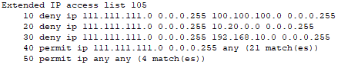
- Only Admin, LAN, WLAN can access IoT server (10.10.10.6).
- Only Admin VLAN can access Data storage (10.10.10.9).
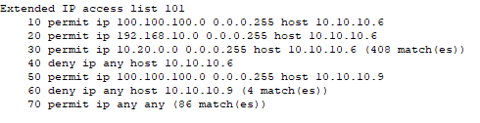

APPENDIX-D: DHCP Pool Configurations
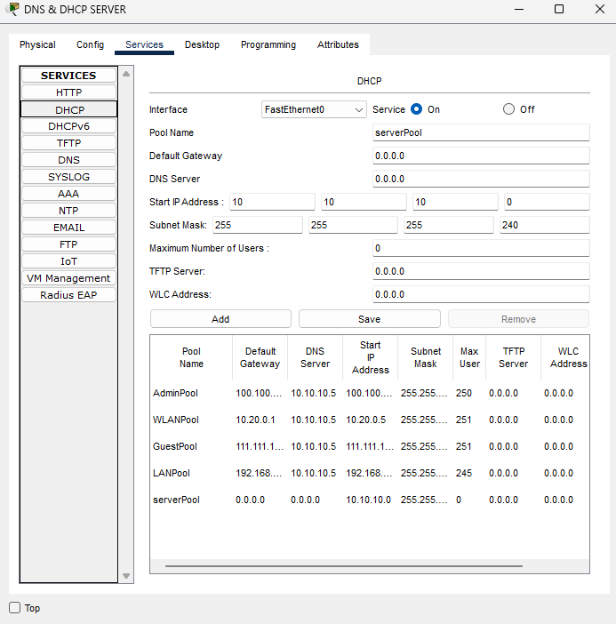

APPENDIX-E: OSPF Process IDs and Router IDs
OSPF 1 for all routers and Core switch.
Router IDs: HEADQUARTERS = 5.5.5.5, BRANCH 1 = 3.3.3.3, BRANCH 2 = 4.4.4.4, ISP = 2.2.2.2, INTERNET=1.1.1.1
All interfaces advertised into OSPF area 0,1 AND 2

APPENDIX-F: VoIP Dial Plan (111–120)
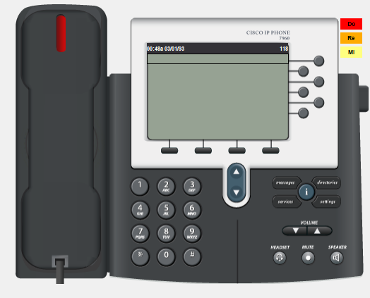

APPENDIX-G: Sample Website
(puc.telco [HOST:INTERNAL SERVER ])
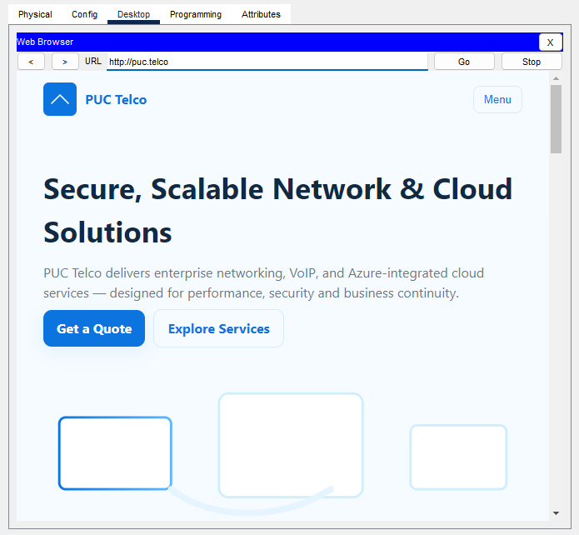
(isp.co[HOST-INTERNET BLOB STORAGE])
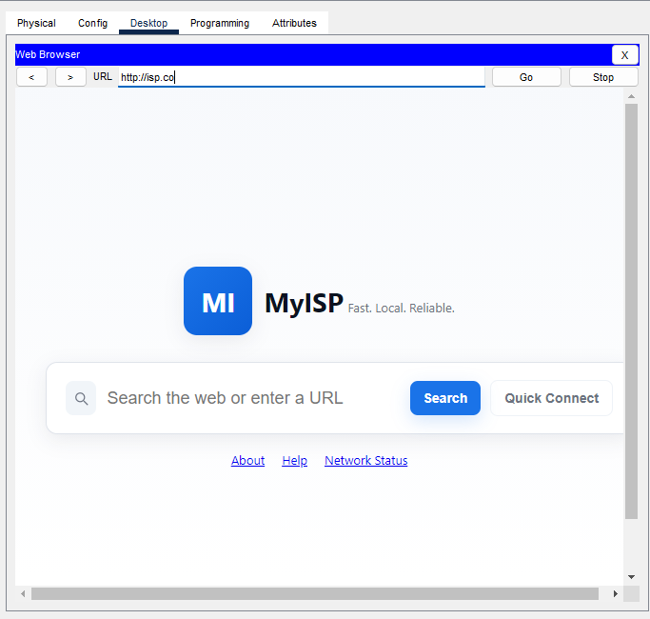

APPENDIX-H: REMOTELY IOT MONITORING AND CONTROL:
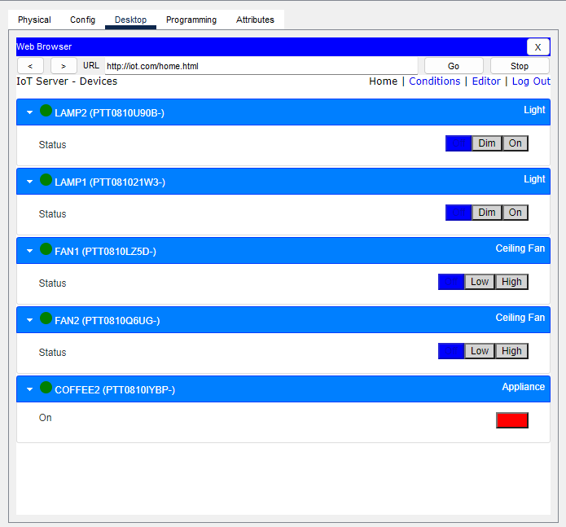

APPENDIX-I: EMAIL
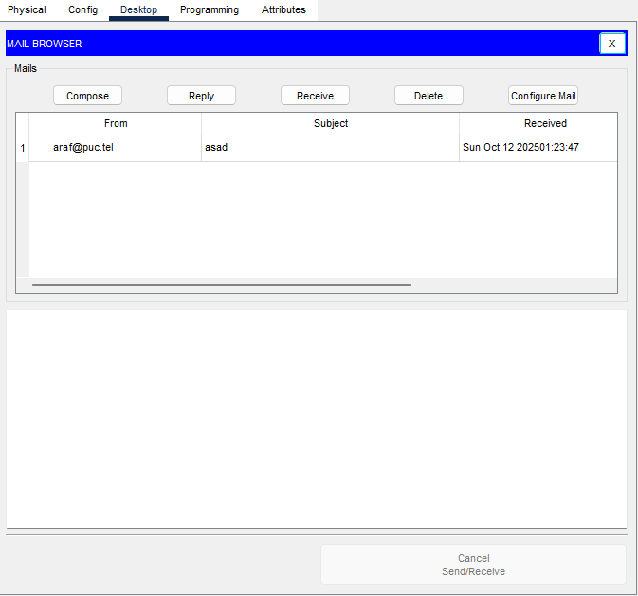

APPENDIX-J: COMPLETE NETWORK

